# Using Density to Determine the Sugar Content in Commercial Beverages

## Procedure

|  |  |
| --- | --- |
| Steps | Observation/Data |
| **Preparing Standard Solutions** | |
| * 1. Obtain four small bottles and label them A, B, C, and D   2. Weight them and record their masses to the nearest 0.01 g.   **Note:** To avoid a congestion at the balances, you can prepare the four solutions one-by-one. | |  |  |  |  | | --- | --- | --- | --- | |  | Mass of empty bottle (g) | Mass of bottle + sugar (g) | Mass of bottle + sugar + water (g) | | Bottle A |  |  |  | | Bottle B |  |  |  | | Bottle C |  |  |  | | Bottle D |  |  |  | |
| * 1. Prepare four standard solutions by following the steps below:  |  |  |  | | --- | --- | --- | | Standard | Amount of sugar (g) | Amount of water (mL) | | Bottle A | 0 | 50.0 | | Bottle B | 2.5 | 48.0 | | Bottle C | 5.0 | 45.0 | | Bottle D | 7.5 | 42.0 |  * 1. Place about the amount of sugar (± 0.1 g) shown in the table in each bottle. Weigh the bottle and sugar and record the mass to the nearest 0.01 g.   2. Using a graduated cylinder, transfer the desired amount of distilled water to each bottle. Record the mass of the solution to the nearest 0.01 g.   3. Cap the bottle and shake thoroughly to dissolve the sugar. |
| * 1. To measure the density of each of the standard solutions, follow the steps below.   2. Weigh a small empty beaker and record its mass.   3. Rinse a 10-ml pipet three times with small amount of the solution to be used.   4. Transfer 10.00 mL of the solution into the beaker.   5. Weigh the beaker + solution, and record the mass.   6. Dispose of the solution, and rinse the beaker with distilled water for the next solution.   7. Repeat steps 7-12 two more times for each solution.   **Note:** If the same beaker is used for each solution there is no need to dry the beaker between solutions, just make sure you record the mass of the empty wet beaker for each solution. | |  |  |  |  |  | | --- | --- | --- | --- | --- | | Solution | Empty beaker (g) | Beaker + solution (g) | Solution (g) | Average mass (g) | | A |  |  |  |  | |  |  |  | |  |  |  | | B |  |  |  |  | |  |  |  | |  |  |  | | C |  |  |  |  | |  |  |  | |  |  |  | | D |  |  |  |  | |  |  |  | |  |  |  | |
| **Determining the Densities of Commercial Beverage Samples** | |
| * 1. Obtain three commercial beverage samples from your laboratory instructor. Record the names of the three samples.   2. To determine the density of the commercial samples follow steps 7-12.   3. Perform each measurement three times for each beverage. | |  |  |  |  |  | | --- | --- | --- | --- | --- | | Beverage | Mass of empty beaker (g) | Mass of beaker + solution (g) | Solution (g) | Average mass of solution (g) | |  |  |  |  |  | |  |  |  | |  |  |  | |  |  |  |  |  | |  |  |  | |  |  |  | |  |  |  |  |  | |  |  |  | |  |  |  | |
|  |

**Densities of Standard Solutions**

|  |  |  |  |  |  |
| --- | --- | --- | --- | --- | --- |
| Standard | Mass of sugar in standard (g) | Mass of standard solution from Steps 1-6 (g) | Average mass of 10.00 mL standard from Steps 7-13 (g) | Sugar content of standard (%) | Density (g/mL) |
| A |  |  |  |  |  |
| B |  |  |  |  |  |
| C |  |  |  |  |  |
| D |  |  |  |  |  |

## Sample Calculations

Standard solutions:

|  |  |  |  |  |  |
| --- | --- | --- | --- | --- | --- |
| Standard | Mass of sugar in standard (g) | Mass of standard solution (g) | Average mass of 10.00 mL standard (g) | Sugar content of standard (%) | Density (g/mL) |
| A | 0 | 50.12 | 9.89 | 0 | 0.989 |
| B | 2.55 | 49.99 | 10.14 | 5.090 | 1.014 |
| C | 5.19 | 50.55 | 10.38 | 10.27 | 1.038 |
| D | 7.95 | 49.45 | 10.66 | 16.07 | 1.066 |

For example, for Standard B solution:



The measurements of commercial beverages:

|  |  |  |  |  |  |
| --- | --- | --- | --- | --- | --- |
| Beverage | Average mass of 10.00 mL (g) | Density of beverage (g/mL) | Sugar content of beverage from graph (%) | Nominal sugar content (%) | % error |
| Sample 1 | 9.8519 | 0.985 | 0.200 | 0.00 | N/A |
| Sample 2 | 10.3777 | 1.038 | 10.75 | 10.00 | 3.10 |
| Sample 3 | 11.0702 | 1.107 | 23.60 | 24.00 | 1.67 |

From the equation on the standardization curve for Sample 2 (see the standardization curve below):



% error for Sample 2 based on the nominal sugar content from the label:



Using the graph instead of the equation 10.2% can be approximated (see red arrows on standardization curve).

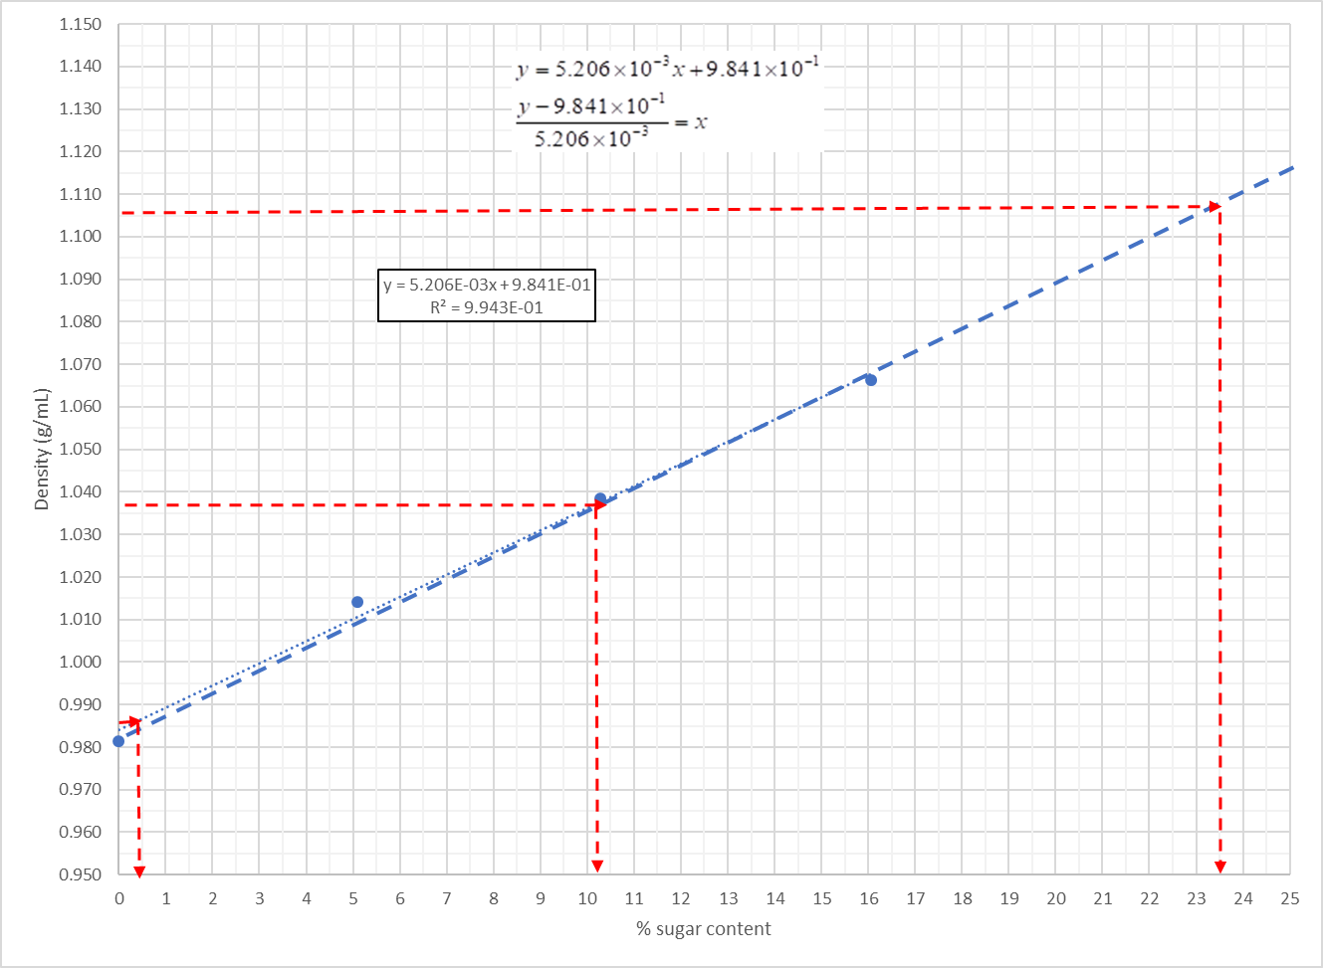

**Note:** There is a video tutorial available with step-by-step instructions how to prepare a standardization curve in Excel (<http://chemistry4.me/CHEM1110L/sugar_lab/Calibrating_curve.html> )

**Densities of Beverages**

|  |  |  |  |  |  |
| --- | --- | --- | --- | --- | --- |
| Beverage | Average mass of 10.00 mL (g) | Density of beverage (g/mL) | Sugar content of beverage from graph (%) | Nominal sugar content (%) | % error |
|  |  |  |  |  |  |
|  |  |  |  |  |  |
|  |  |  |  |  |  |