- Label two 150-mL beakers and weigh them.
- Plug in a hotplate and turn it on to high temperature.
- Weigh between 2.5 and 3.0 g of the mixture into Beaker 1, and record the masses to the nearest 0.001 g.
- Add 50 mL water to the mixture, and stir it for about 5 min with a glass rod.
- Assemble a filtration apparatus as shown with a folded filter paper like a coffee filter (Figure 1) in the funnel and with Beaker 2 under the funnel (Figure 2).
Note: Make sure the long end of the tapered tip of the funnel touches the inner wall of the beaker for faster drain.
- Swirl the content of Beaker 1 and pour some into the funnel.
- Repeat step 6 until there is any liquid in Beaker 1.
- Hold Beaker 1 over the funnel tilted with the opening down, and squirt small portions of water from a squeeze bottle to wash the solid residue into the funnel (Figure 3).
Note: try to minimize the added water, as all of the water has to be evaporated, which is time consuming.
- Squirt some water from a squeeze bottle into the filter paper to wash any NaCl residue.
- When the filtration is complete, place Beaker 2 with the filtrate on the hot plate, and set the hot plate to medium temperature.
Note: Proceed to the next step, but keep an eye on this beaker, and when most of the water evaporated and it starts sputtering lower the temperature, take off the beaker with tongs until the sputtering stops, then place it back. When the reside is snow white, the evaporation is complete, and then place the beaker on a cooling surface.
- Weigh an empty evaporation dish.
- Wash the solid residue from the filter paper into the evaporating dish with a gentle stream of water from a squeeze bottle (Figure 4).
Note: try to minimize the amount water used.
- Pour 8.0 mL 3M HCl solution slowly into the evaporating dish, and mix until there is gas formation. The milky liquid becomes transparent with the sand particles are clearly visible.
- Rinse Beaker 1, and decant the clear liquid from the evaporating dish into it.
- Wash the sand residue twice with small amount of water from a squeeze bottle. Collect all the liquid in Beaker 1.
- Place Beaker 1 on the hot plate. Once it starts to boil, keep boiling it for 5 min, then remove it from the hot plate with tongs and place it on a cooling surface. While waiting, proceed to the next step.
- Place the evaporating dish on the hot plate, and start to heat it. If it starts to sputter, hold it off the hot plate with tongs until the sputtering stops, and place it back on the hot plate until the sand clumps up. When the sand grains freely move, remove the evaporating dish from the hot plate with tongs, and place it on a cooling surface.
- After removing Beaker 1 from the hot plate, add slowly 15 mL 1 M K₂CO₃ solution, and stir the solution for 3 min.
Note: Ample amount of white precipitate should appear. If there is only a small amount or no precipitation, add more K₂CO₃ solution with a disposable dropper until precipitation occurs, while continuously stirring.
- Once the evaporating dish cooled down, weigh it.
- Scrape out as much sand as you can from the evaporating dish (but don’t wet it!), and weigh it with a clean filter paper added.
- Assemble the filtration apparatus with the filter paper folded as before, weighed with the evaporating dish, and with any beaker under the funnel.
Note: Make sure the long end of the tapered tip of the funnel touches the inner wall of the beaker for faster drain.
- Swirl the content of Beaker 1 and pour some into the funnel.
- Repeat step 22 until there is any liquid in Beaker 1.
- Hold Beaker 1 over the funnel tilted with the opening down, and squirt small portions of water from a squeeze bottle to wash the solid residue into the funnel.
- Squirt some water from a squeeze bottle into the filter paper to wash off any K₂CO₃ residue into the waste.
- Place the evaporating dish on the hot plate, and place the filter paper with the residue in the evaporating dish.
- Move the paper around with the tong for better contact with the wall of the evaporating dish.
Note: make sure the paper doesn’t burn or turn brown.
- Once the paper is dry, move the evaporating dish onto a cooling surface.
- Once it cooled down, weigh it.
- Weigh the cooled Beaker 2 as well.

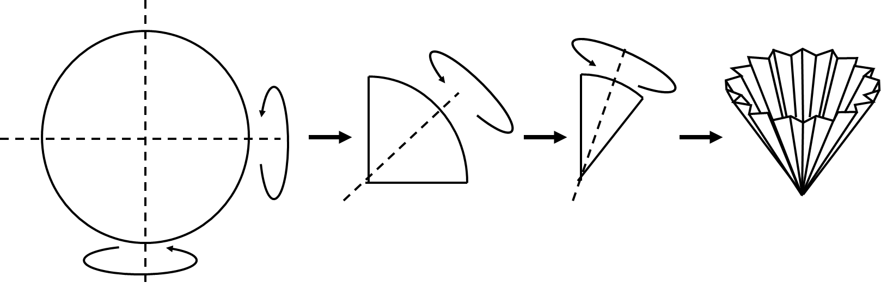 | 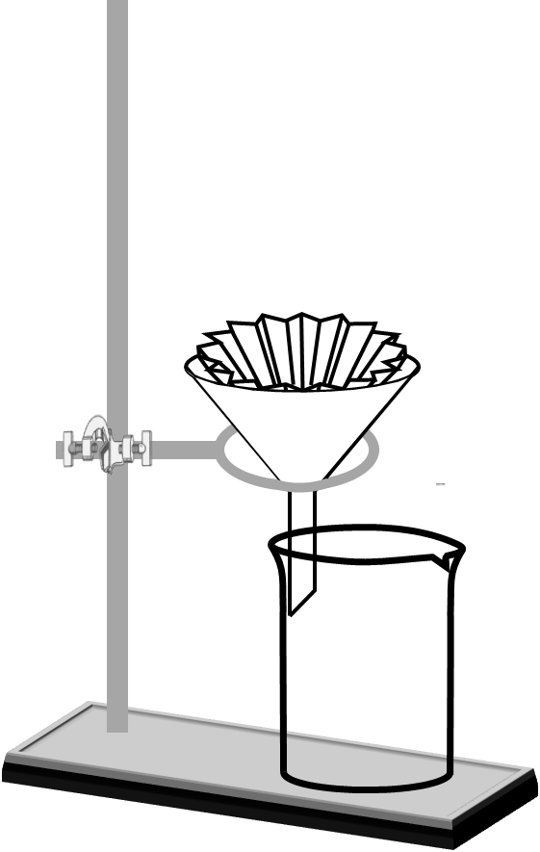
Figure 1 | Figure 2
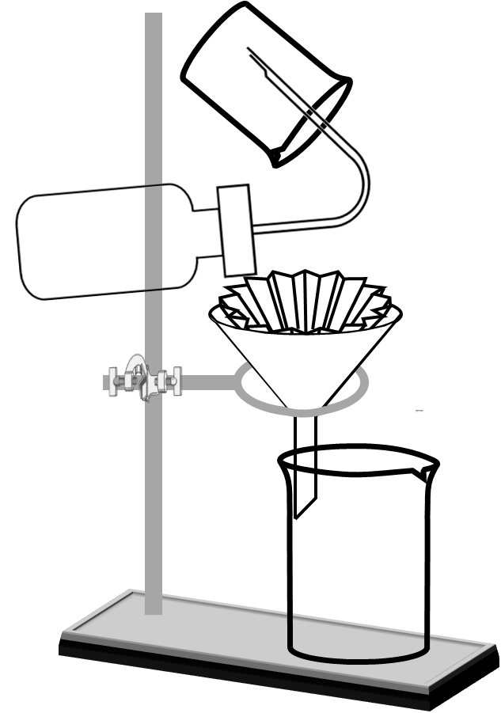 | 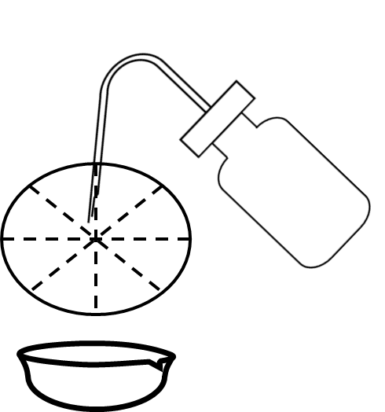
Figure 3 | Figure 4

