Separation of the Components of a Mixture

Background
Substances that have more than one component are called mixtures. One characteristics of mixtures is their uniformity. If the composition doesn’t vary from region to region on the molecular level, it is called a homogeneous mixture, for example gasoline which has hundreds of different compounds, yet it is uniform on the molecular level.
Mixtures that are not uniform throughout, their composition varies from region to region inside the mixture, are called heterogeneous mixtures. For example, gasoline and water are not miscible and when they are mixed, they form separate layers: the gasoline on the top, and water on the bottom (water having higher density than the components of gasoline). Gasoline with poor quality can have some water, which will accumulate on the bottom of the gas tank over time causing car troubles (like in winter time water can freeze in the gas lines if the fuel level in the gas tank is too low).
The components of a mixture can be separated using the difference in their physical properties, such as solubility and volatility. For example, the difference in volatility is used when crude oil is processed using distillation to separate gasoline, diesel, kerosene, etc. (which by themselves are homogeneous mixtures of many compounds).
The separation of components of a mixture (homogeneous or heterogeneous) using the difference in their physical properties leaves the components unchanged in their chemical identity. Chemical changes to the components can be leveraged to separate a component, however another chemical change has to be applied to recover the original compound. For example, in this lab the CaCO₃ component (which is not soluble in water) is dissolved with HCl with in a chemical reaction to separate it from sand (with filtration), and in a later process recovered with another chemical process.
In this lab the components of a heterogenous solid mixture of NaCl, CaCO₃, and sand are separated using the difference in their physical and chemical properties.

Sample Calculations

Mass of the original sample: | 2.876 g
Mass of recovered sand: | 1.213 g
Mass of recovered CaCO₃: | 0.876 g
Mass of recovered NaCl: | 0.567 g

Total mass of the recovered sample (NaCl + sand + CaCO₃):
Composition of mixture from the recovered sample:

Procedure

Step | Observations/Notes
- Review the whole procedure before starting (Figure 1). In the interest of saving time some steps are to be performed parallel with each other.
- Label two 150-mL beakers and weigh them (Beaker 1 and Beaker 2). | Mass of Beaker 1 (g):  Mass of Beaker 2 (g):
- Plug in a hotplate and turn it on to high temperature.
Note: make sure there is nothing around the hot plate and the electrical cord is clear from the heated surface.
- Weigh between 2.5 and 3.0 g of the mixture into Beaker 1, and record the masses to the nearest 0.001 g. | Mass of Beaker 1 (g) (from Step 1):  Mass of Beaker 1 + sample (g):  Mass of sample (g):
- Add 50 mL water to the mixture, and stir it for about 5 min with a glass rod.
- Assemble a filtration apparatus as shown with a folded filter paper like a coffee filter (Figure 2) in the funnel and with Beaker 2 under the funnel (Figure 3).
Note: Make sure the long end of the tapered tip of the funnel touches the inner wall of the beaker for faster drain.
- Swirl the content of Beaker 1 and pour some into the funnel.
- Repeat step 7 until there is any liquid in Beaker 1.
- Hold Beaker 1 over the funnel tilted with the opening down, and squirt small portions of water from a squeeze bottle to wash the solid residue into the funnel (Figure 4).
Note: Try to minimize the added water, as all of the water has to be evaporated, which is time consuming.
- Squirt some water from a squeeze bottle into the filter paper to wash any NaCl residue into the filtrate.
- When the filtration is complete, place Beaker 2 with the filtrate on the hot plate, and set the hot plate to medium temperature.
Note: Proceed to the next step, but keep an eye on Beaker 1, and when most of the water evaporated and it starts to sputter lower the temperature, take off the beaker with tongs until the sputtering stops, then place it back. When the residue is snow white, the evaporation is complete, and then place the beaker on a wire gauze on the bench.
- Weigh an empty evaporation dish. | Mass of empty evaporating dish (g):
- Wash the solid residue from the filter paper into the evaporating dish with a gentle stream of water from a squeeze bottle (Figure 5).
Note: try to minimize the amount water used.
- Pour 8.0 mL 3M HCl solution slowly into the evaporating dish and mix until there is gas formation. The milky liquid becomes transparent with the sand particles clearly visible.
- Clean Beaker 1 with water, and decant the clear liquid from the evaporating dish into it.
- Wash the sand residue in the evaporating dish twice with small amount of water from a squeeze bottle into Beaker 1. Collect all the liquid in Beaker 1.
- Place Beaker 1 on the hot plate. Once it starts to boil, keep boiling it for 5 min (or until the volume is about half of the original volume), then remove it from the hot plate with tongs and place it on a wire gauze on the bench. While waiting for the boiling, proceed to the next step.
Note: Don’t allow the solution to go dry.
- Place the evaporating dish on the hot plate, and start to heat it. If it starts to sputter, hold it off the hot plate with tongs until the sputtering stops (Figure 6), and place it back on the hot plate until the sand clumps up. When the sand grains freely move, remove the evaporating dish from the hot plate with tongs, and place it on a wire gauze on the bench.
- After removing Beaker 1 from the hot plate, add slowly 15 mL 1 M K₂CO₃ solution, and stir the solution for 3 min.
Note: Ample amount of white precipitate should appear. If there is only a small amount or no precipitation, add more K₂CO₃ solution dropwise with a disposable dropper until precipitation occurs, while continuously stirring.
- Once the evaporating dish cooled down, weigh it. | Mass of empty evaporating dish (from Step 12) (g):  Mass of evaporating dish + sand (g):  Mass of sand (g):
- Scrape out as much sand as you can from the evaporating dish (but don’t wet it!) and weigh it with a clean filter paper added. | Mass of empty evaporating dish + filter paper (g):
- Assemble the filtration apparatus with the filter paper folded as before, weighed with the evaporating dish, and with any beaker under the funnel.
Note: Make sure the long end of the tapered tip of the funnel touches the inner wall of the beaker for faster drain.
- Swirl the content of Beaker 1 and pour some into the funnel.
- Repeat step 23 until there is any liquid in Beaker 1.
- Hold Beaker 1 over the funnel tilted with the opening down, and squirt small portions of water from a squeeze bottle to wash the solid residue into the funnel.
- Squirt some water from a squeeze bottle into the filter paper to wash off any K₂CO₃ residue into the waste.
- Place the evaporating dish on the hot plate, and place the filter paper with the residue in the evaporating dish.
- Move the paper around with the tong for better contact with the wall of the evaporating dish.
Note: make sure the paper doesn’t burn or turn brown.
- Once the paper is dry, move the evaporating dish onto a wire gauze.
- Once it cooled down, weigh it. | Mass of evaporating dish + filter paper + sample (g):  Mass of empty evaporating dish + filter paper (from step 21) (g):  Mass of CaCO₃ (g):
- Weigh the cooled Beaker 2 as well. | Mass of Beaker 2 + sample (g):  Mass of Beaker 2 (from Step 1) (g):  Mass of NaCl (g):

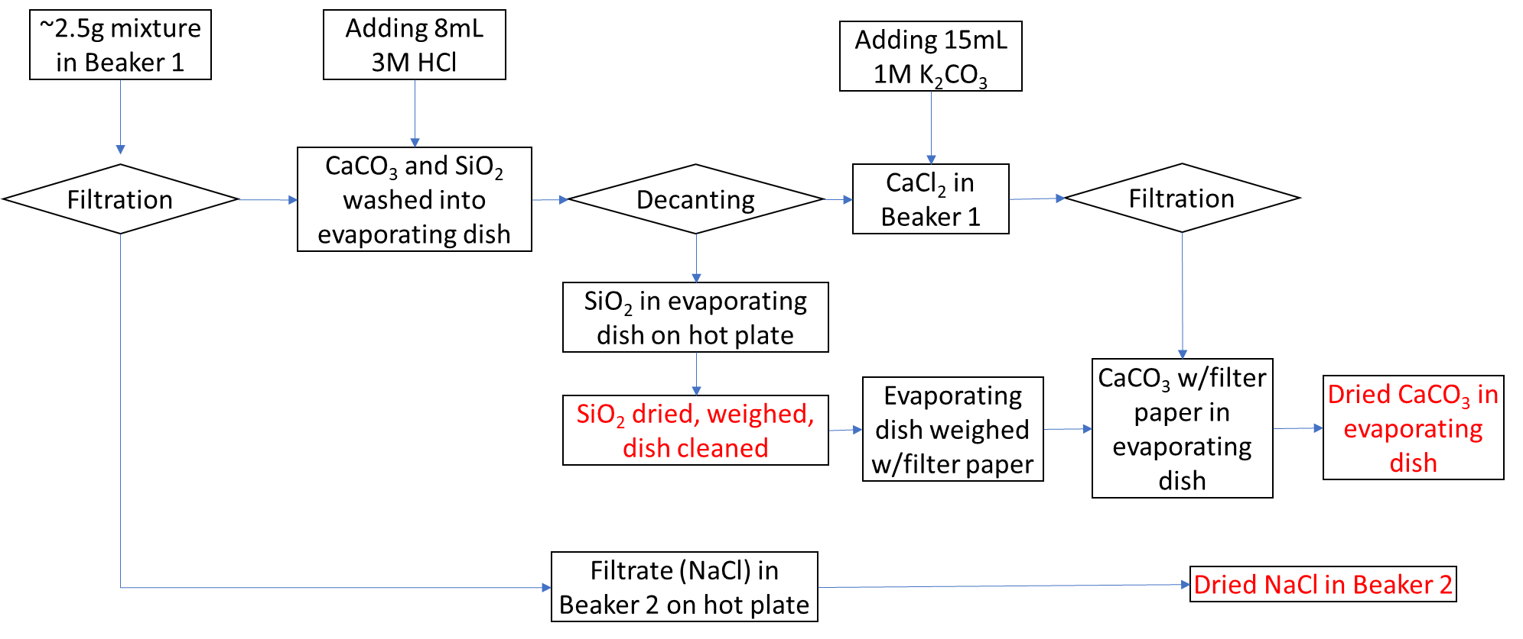
Figure 1
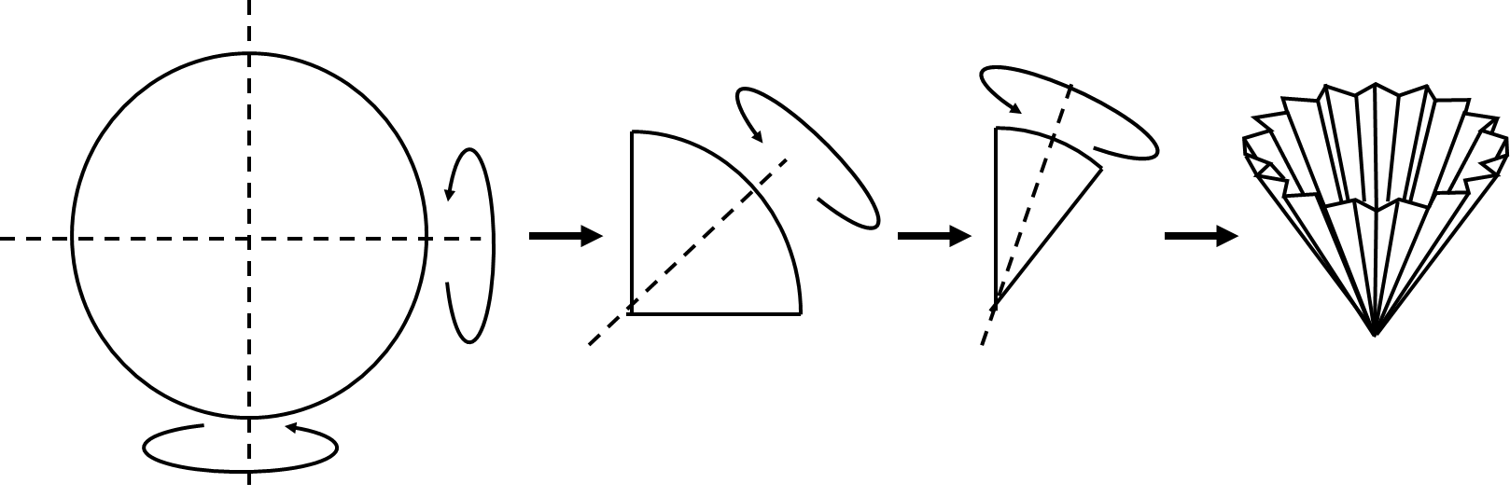 | 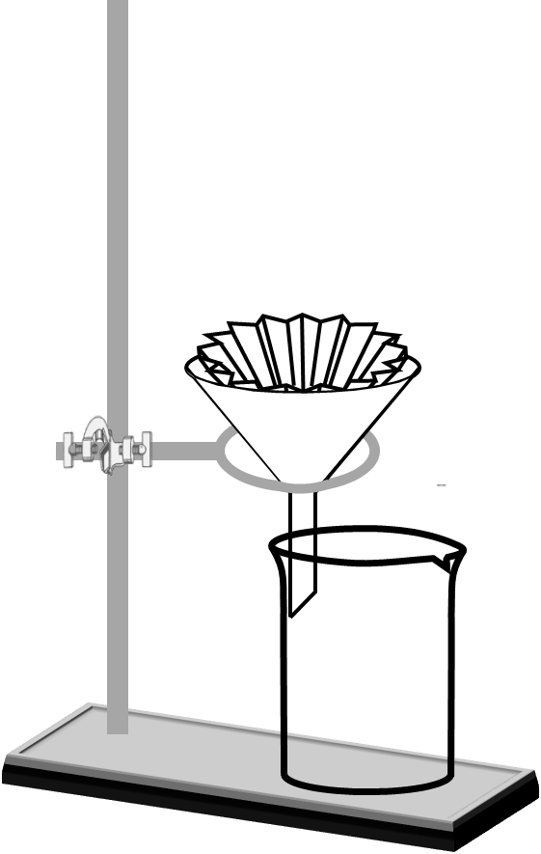
Figure 2 | Figure 3
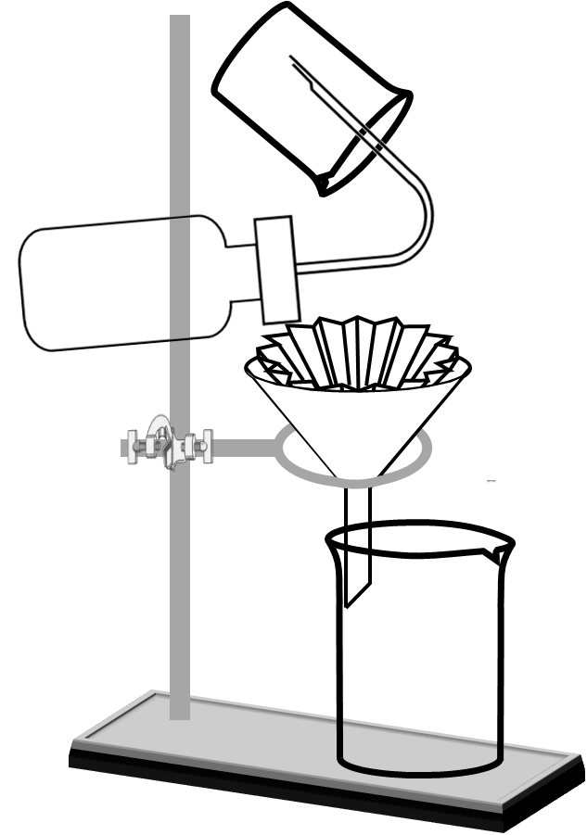 | 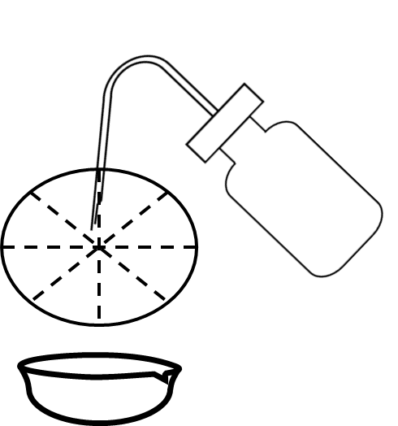
Figure 4 | Figure 5
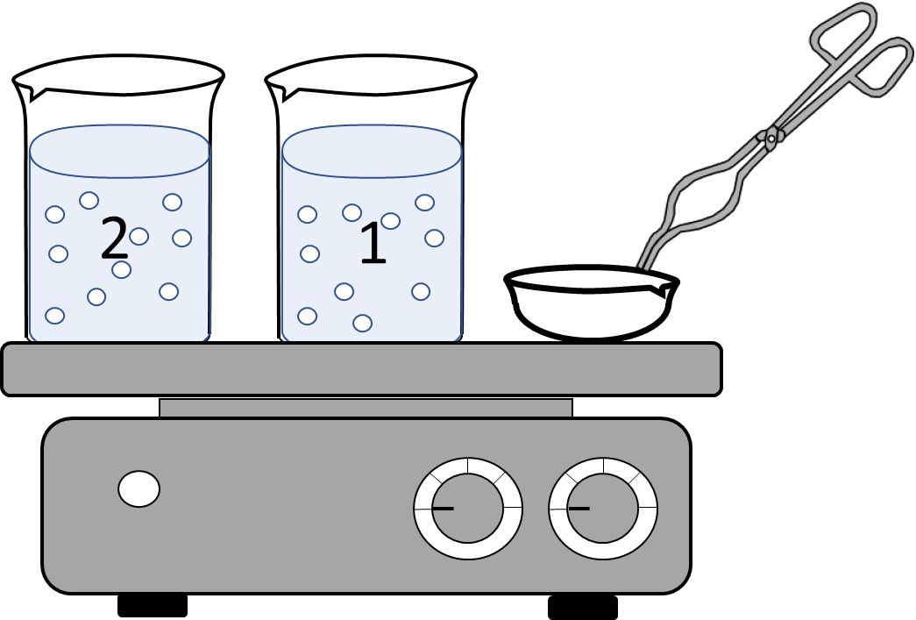
Figure 6

Data Table:

Mass of the original sample (from Step 4) (g): | g
Mass of sand (from Step 20): | g | %
Mass of CaCO₃ (from Step 30) (g): | g | %
Mass of NaCl (from Step 31) (g): | g | %
Mass of the original sample (from Step 4) (g): | g
Mass of the recovered sample (NaCl + sand + CaCO₃) (g): | g
Yield (%):

